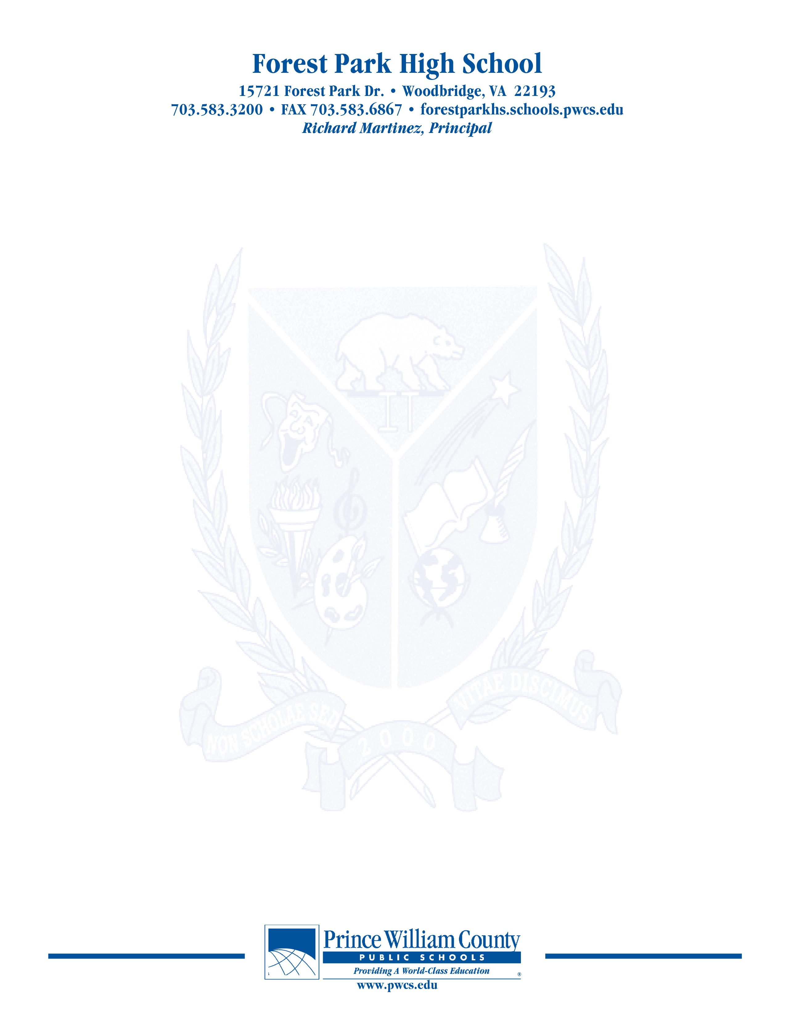

**PAC – Principal’s Advisory Council**

Monday, September 27, 2021

**7:00 pm Welcome**

**7:05 pm School Highlights- What good things are happening in the Den?**

**710pm Advisory Council Training**

**715pm Update on SACI Information**

**7:20 pm Principal Martinez’ Report**

**Budget**

**Staffing**

**Quarantine and FP Academy**

**Updates to building**

**7:45pm Open Chair**

**8:00 pm Concluding Remarks & Adjournment**

***Our next meeting will take place on October 25, 2021***

***The purpose of the Forest Park Senior High School Principal's Advisory Council provides feedback and recommendations to the Principal pertaining to the annual school improvement plan (hereafter, “the School Plan”). The PAC is not a forum to discuss personal or individual issues relating to any particular student or parent.***