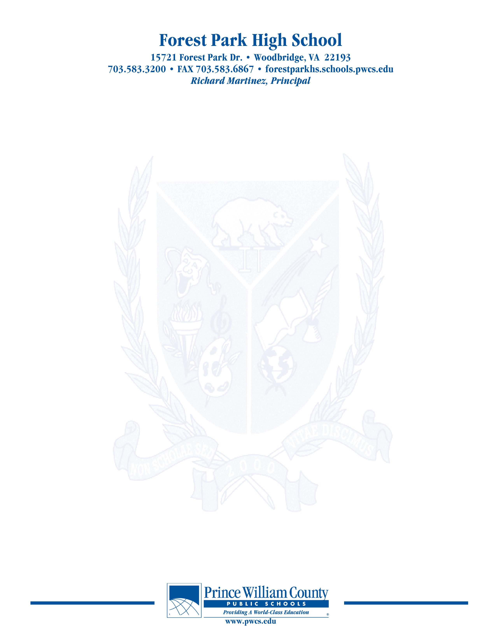

**PAC – Principal’s Advisory Council**

Monday October 25, 2021

**7:00 pm Welcome**

**7:05 pm School Highlights- What good things are happening in the Den?**

**7:10 pm PAC Business**

**7: 15pm Update on SACI**

**7: 20pm Principal Martinez’ Report**

**7:45pm Open Chair**

**8:00 pm Concluding Remarks & Adjournment**

***Our next meeting will take place on November 29, 2021***

***The purpose of the Forest Park Senior High School Principal's Advisory Council provides feedback and recommendations to the Principal pertaining to the annual school improvement plan (hereafter, “the School Plan”). The PAC is not a forum to discuss personal or individual issues relating to any particular student or parent.***