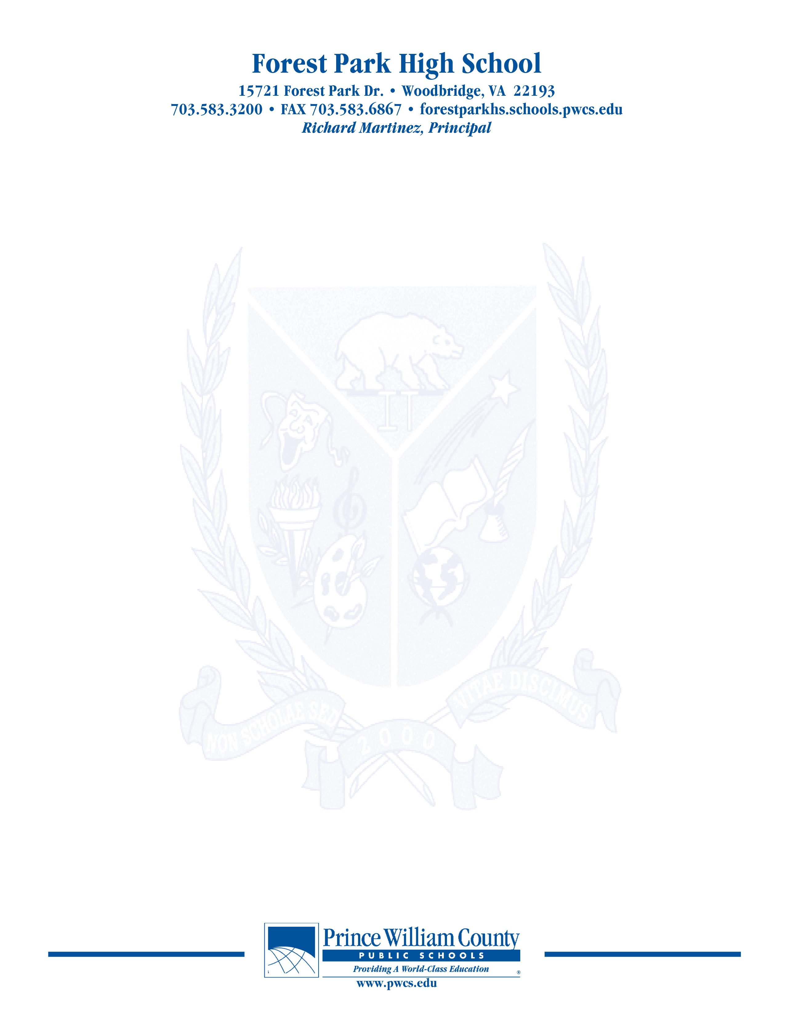

**PAC – Principal’s Advisory Council**

Monday, November 29, 2021

**7:00 pm Welcome**

**7:05 pm School Highlights- What good things are happening in the Den?**

**710pm SACI Update**

**7:20 pm Principal Martinez’ Report**

**Budget**

**School Plan**

**Events**

**School Safety**

**7:45pm Open Chair**

**8:00 pm Concluding Remarks & Adjournment**

***Our next meeting will take place on January 31, 2022***

***The purpose of the Forest Park Senior High School Principal's Advisory Council provides feedback and recommendations to the Principal pertaining to the annual school improvement plan (hereafter, “the School Plan”). The PAC is not a forum to discuss personal or individual issues relating to any particular student or parent.***