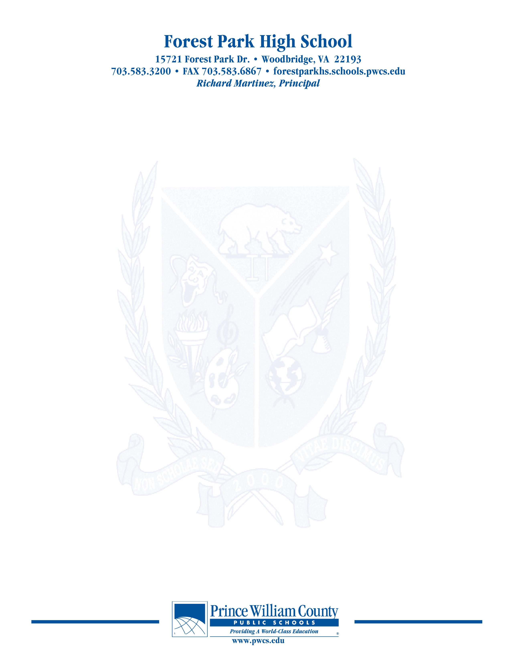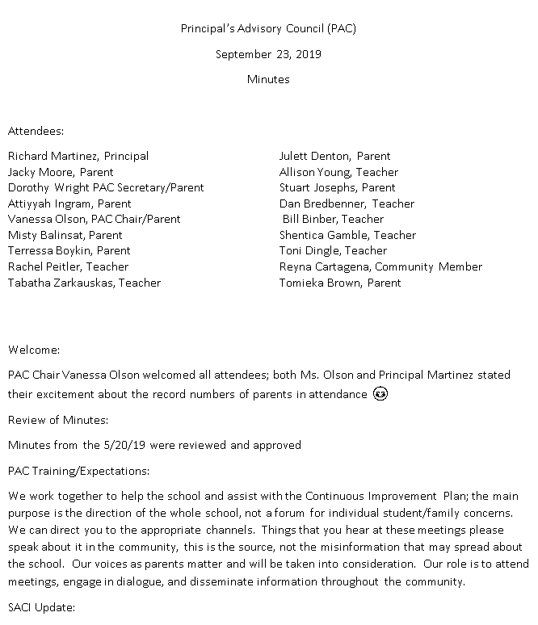

Principal’s Advisory Council (PAC)

May 18, 2020

Minutes

Zoom Meeting

Attendees: (Attendance was “collected” from screen names of attending members, may need to be corrected)

Richard Martinez, Principal Vanessa Olson, PAC Chair/Parent

Julett Denton, PAC Co-Chair/Parent Jacky Moore, Parent

Matthew Harman, Assistant Principal Tomieka Brown, Parent

Jennifer Chapman, Assistant Principal Brian Parke, Athletics and Activities

James Smith, Assistant Principal

John Geisinger, Assistant Principal

Steve Smith, Director of School Counseling

**This meeting of the Forest Park PAC took place via Zoom.**

**Welcome:**

Mrs. Olson welcomed everyone

It was proposed and accepted that the current officers remain in place until next school year when the council will meet again. At that time we will elect the board for the 2020-2021 school year.

**Update on SACI**

* The end of the year report for SACI was developed remotely during the month of March. Members were asked to provide feedback in relation to the topics covered this year in SACI. Topics included grading, curriculum changes, movement and recess, the strategic plan, and mental health. Across all topics, the main concern was the distribution of the information presented to the public. A list of possible topics for next year was also identified and next years council will determine which of the identified topics will be addressed that year.

**Principal Martinez’ Report**

* PWCS sped up the process of bringing technology to a 1 to 1 status. Forest Park contributed $400,000. The First batch of computers from this effort is coming in Friday (May 22). Once set up, they will be distributed first to the rising Juniors and Seniors. The second batch is expected in October.
* During the quarantine period we had 40 staff members with issues with technology and we had to purchase additional devices.
* Connectivity continues to be an issue.
* Turf field update- the contract had to go back out to bid. The original bids had a discrepancy in the scope of the work between the proposals. When the bids come back in, we will see what happens next. Hopefully the contract will be awarded at the June School Board meeting and ground breaking will occur at the end of June. All Fall sports are scheduled to be away games until Oct. 1st.
* We are working on organizing the distribution of
  + Caps and Gowns to seniors
  + Technology
  + Need the community to update contact information to facilitate communication.

***The purpose of the Forest Park Senior High School Principal's Advisory Council provides feedback and recommendations to the Principal pertaining to the annual school improvement plan (hereafter, “the School Plan”). The PAC is not a forum to discuss personal or individual issues relating to any particular student or parent.***

* We have filled 17 of the 22 open positions.
* Students need to complete turning in homework before the last week of school to allow time for updating grades.
* Working on learning the new CANVAS learning platform
* We are working on the plan to get items to students. We are currently bagging and tagging locker items. We are waiting to the Governor’s decision to start letting people into the building to start the distribution.
* Seniors- we are trying to do something big in August. Goal is to have something on June 5th- drive by to pick up diplomas. We are working on a senior celebration video.
* Summer assignments will not be assigned this year.

**School Improvement Plan**

* Have increased number of AP enrollments in Math
* Standards based grading- Collaborative Learning Team (CLT) cohort completed training in common planning- What do we want them to learn, how do we know if they learned it, and what do we do if they have not learned it. Next year is Phase II where we roll it out to the other teachers. The Divisions approach to the 4th quarter has led to teachers having different conversations.
* School culture- environment changes has brought this to a halt.

**Concluding Remarks & Adjournment**

Adjourn 7:50

**Our next meeting will take place in September 2020. Date and time TBD**

***The purpose of the Forest Park Senior High School Principal's Advisory Council provides feedback and recommendations to the Principal pertaining to the annual school improvement plan (hereafter, “the School Plan”). The PAC is not a forum to discuss personal or individual issues relating to any particular student or parent.***