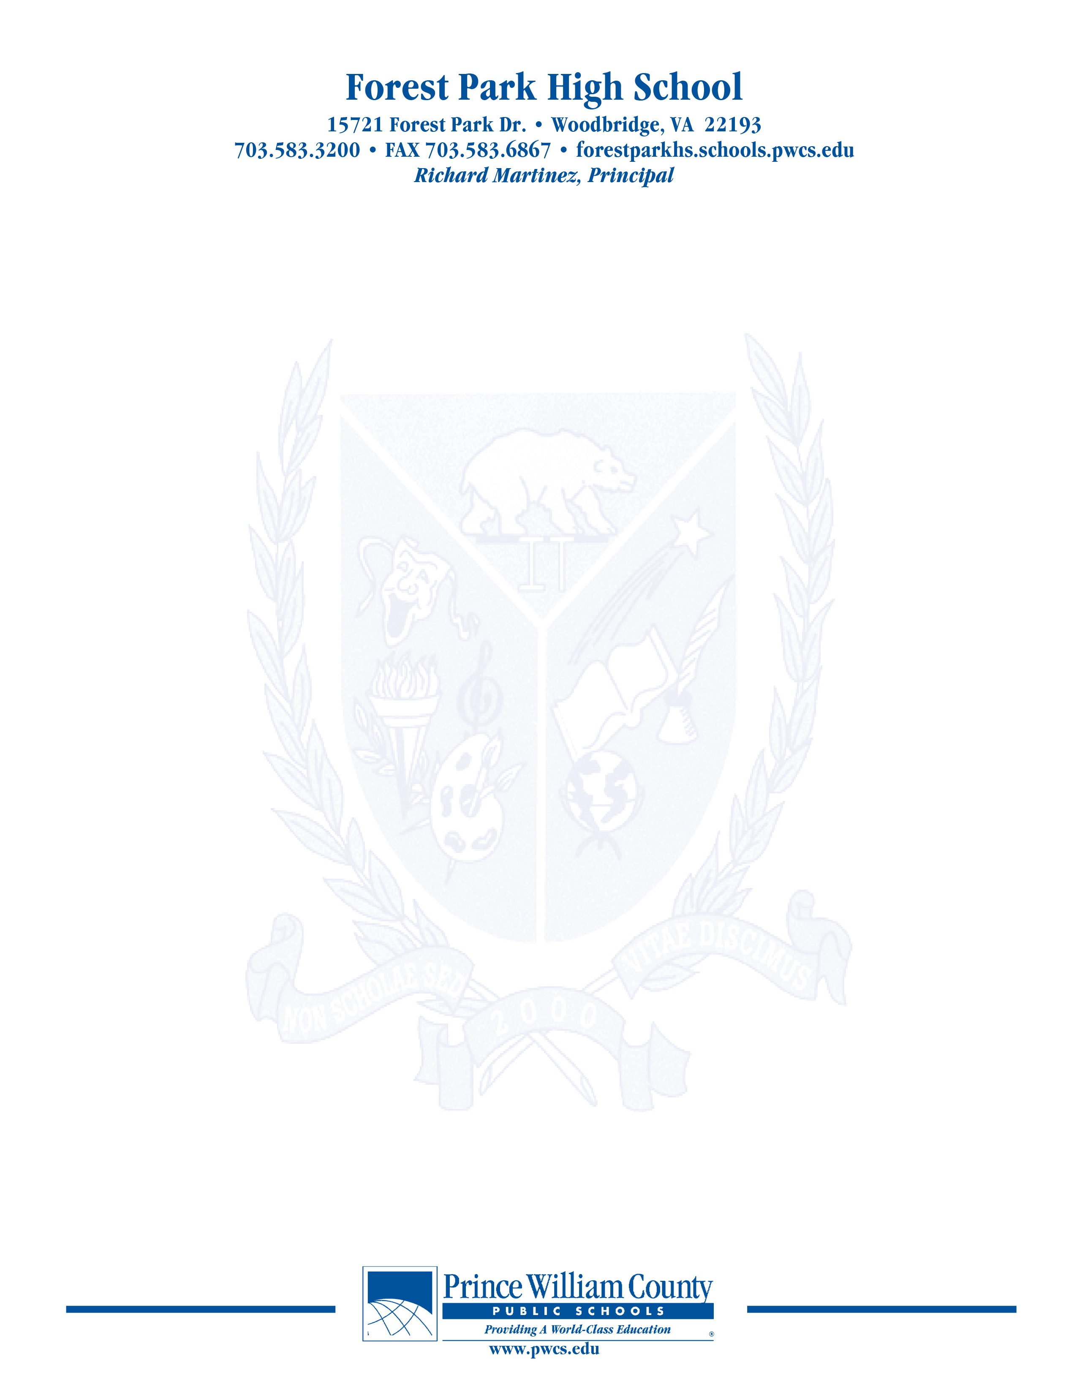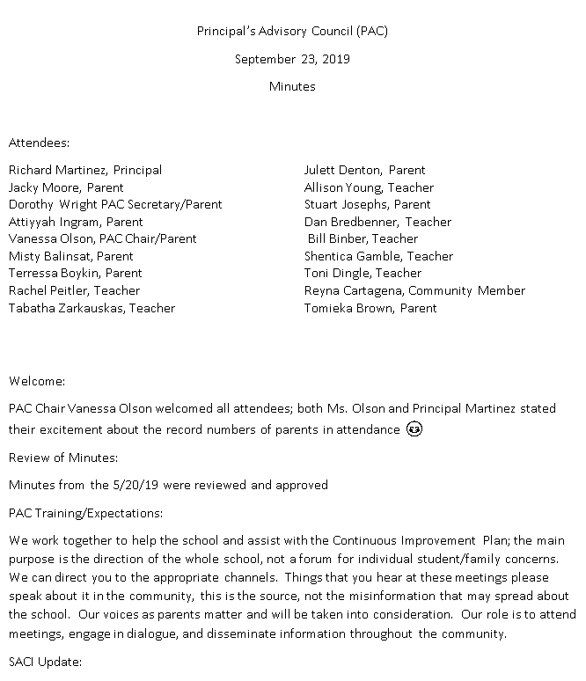

Principal’s Advisory Council (PAC)

February 10, 2020

Minutes

Attendees: (Attendance sheet was not collected at the end of the night, attendance will need to be corrected)

Richard Martinez, Principal Vanessa Olson, PAC Chair/Parent

Julett Denton, PAC Co-Chair/Parent Jacky Moore, Parent

Tabatha Zarkauskas, Teacher Shemica Gamble, Teacher

Allison Young, Teacher Ariyaria Brown-Watts, Student

Dan Bredbenner, Teacher John Geisinger, Assistant Principal

Rachel Peitler, Teacher

**Welcome:**

Mrs. Olson welcomed everyone

**Review of Minutes:**

Approved as written

**Update on SACI**

* There has not been a SACI meeting since our last PAC meeting. This week SACI will sponsor the Best Practices Conference for Parents. Next month we will be working on the annual report. If there are any areas of concern that members of the PAC would like to see discussed for possible inclusion in the report please let Vanessa Olson know prior to the March 12th date. We will be discussing lunch debt and highlight experiences with the HUB.

**Principal Martinez’ Report**

* Update on the installation of the new turf fields. They are hoping to begin construction in early April. The expected cost will be $1.3 million. As a part of the construction we are seeing if we can do a few extra things such as move the pole vault, putting in a new shed to store equipment to maintain the turf, water fountains by the filed, and if we can light up the flag pole. We are hoping that construction will be complete by late July. Right now the plans are at the county for final approval of permits.
* It was just announced today that March 3 will now be a student holiday because of the primary election.
* Commencement will take place at 2pm on June 5 at Eagle Bank Arena.
* Budget Projections- we are looking to add additional positions in Math, English, EL, and LD classrooms.
  + Projected number of students for 2020-21 is 2196 (we are currently at 2221)
  + Projected budget $17.3 million
  + Fixed costs- 2.5 million, Staffing of 186.6 positions = $16.3 million = 93.3% of budget
  + The budget numbers will be cleaned up in May once final budgets are approved and new numbers come in.
* What is happening
  + New AI phone for entry into the building is in full use.
  + Added blinds to the side door windows
  + Added security
  + We are looking at improving video displays in the building (ie smart boards)

***The purpose of the Forest Park Senior High School Principal's Advisory Council provides feedback and recommendations to the Principal pertaining to the annual school improvement plan (hereafter, “the School Plan”). The PAC is not a forum to discuss personal or individual issues relating to any particular student or parent.***

* We are working with the energy office to replace the theatre lights
* Looking to remodel the front office so everyone has appropriate working space
* Purchasing class desks
* Remodeling media center
* Planning the 20th Anniversary Celebration
* There are a number of different logos that are being used around the building. We are working with a company to develop a few different official logos that can be used. We will be working on trademark protection for these new logos.

**Open Chair**

Discussion of Touch Base.

Discussion of calendar and start dates. Next year we will be starting on a Tuesday. We discussed the date of Back to School night. It will be the Thursday night of the first week of school.

**Concluding Remarks & Adjournment**

Adjourn 7:50

**Our next meeting will take place on March 23, 2020**

***The purpose of the Forest Park Senior High School Principal's Advisory Council provides feedback and recommendations to the Principal pertaining to the annual school improvement plan (hereafter, “the School Plan”). The PAC is not a forum to discuss personal or individual issues relating to any particular student or parent.***