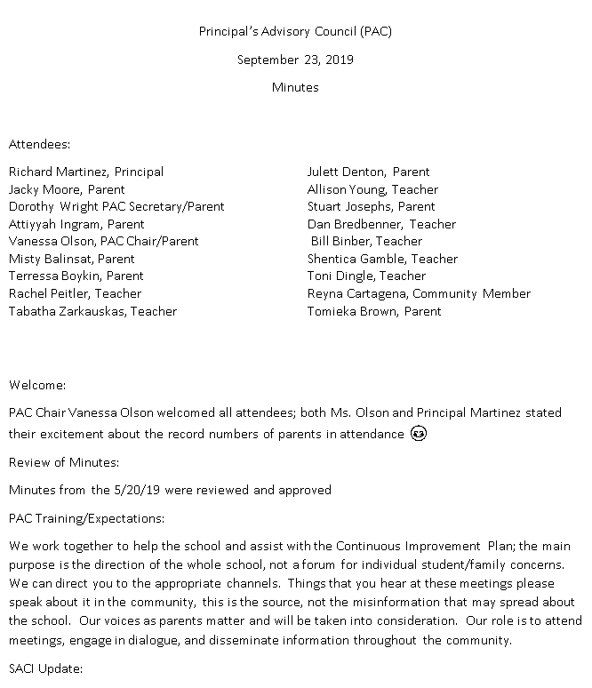

Principal’s Advisory Council (PAC)

November 18, 2019

Minutes

Attendees:

Richard Martinez, Principal

Vanessa Olson, PAC Chair/Parent

Julett Dentton, PAC Co-Chair/Parent

Jacky Moore, Parent

Tabatha Zarkauskas, Teacher

Shemica Gamble, Teacher

Allison Young, Teacher

**Welcome:**

Mrs. Olson welcomed everyone

**Review of Minutes:**

Approved as presented.

**Update on SACI**

* We had a presentation on mental health
  + Discussed members of the mental health team
  + Curriculum services offered to all students
    - In high school- 9th Grade cover sexual harassment, signs of suicide
      * + 10 Stress management
        + 12th grade- there is a pilot program at Patriot addressing college students and mental health. The plan is to bring this program to additional schools.
  + Mental Health programs for parents/families
    - Fall and Spring Mental health summit
    - Fall Parent Camp (Through the Title 1 office)
    - There is a planned comprehensive online parent resource email
    - Individual school-based parent workshops
* Strategic Plan
  + In the beginning stages of development of the Strategic plan to cover 2021-20205
  + Looking at themes that get us to student achievement and who plays a role
    - Equity
    - Climate and Culture
    - Family Engagement
    - Organizational supports
  + There will be multiple ways parent will be able to give feedback in this process.
* Update on Advisory Council Training- there is online videos on how to run an advisory council. Looking to have alignment between schools.

***The purpose of the Forest Park Senior High School Principal's Advisory Council provides feedback and recommendations to the Principal pertaining to the annual school improvement plan (hereafter, “the School Plan”). The PAC is not a forum to discuss personal or individual issues relating to any particular student or parent.***

**Principal Martinez’ Report**

There will be a meeting with the company who will be installing the new Turf field. But we do not have any information yet. Based on what happens with the timeline, we will make decisions on spring sports. Weather is going to be a major factor.

There is a concern about the softball fields. There are no restroom facilities there. We have inquired about a porta potty. Vandalism is a concern.

We are moving forward with the shed installation.

We will be attending Collaborative learning team training and will implement best practices that come out of that.

In relation to the budget

* + Looking at other security needs
  + Looking at cameras
  + Looking at the auditorium- we have torn theater curtains, want to convert lighting to LED, looking into turning the boarders along carpeted areas into LED strips
  + On Catwalks there are 3 lights where there should be 20
  + We are looking into bringing a sound system into the enclosed cafeteria
  + We have technology that is dying
  + We don’t have an administrator upstairs, but we need the space so looking into options
  + Looking into improvements for the A Street Bistro

**Open Chair**

There were two questions submitted ahead of the meeting. The first was about the fields and impact on spring sports. Information will be shared as soon as it is available. There was a second question about students parking in the adjoining neighborhoods and blocking driveways, etc. The question was posed if the school could make announcements about following the rules. It was discussed that these announcements are made regularly.

**Concluding Remarks & Adjournment**

Adjourn 8:02

**Our next meeting will take place on January 13, 2020**

***The purpose of the Forest Park Senior High School Principal's Advisory Council provides feedback and recommendations to the Principal pertaining to the annual school improvement plan (hereafter, “the School Plan”). The PAC is not a forum to discuss personal or individual issues relating to any particular student or parent.***