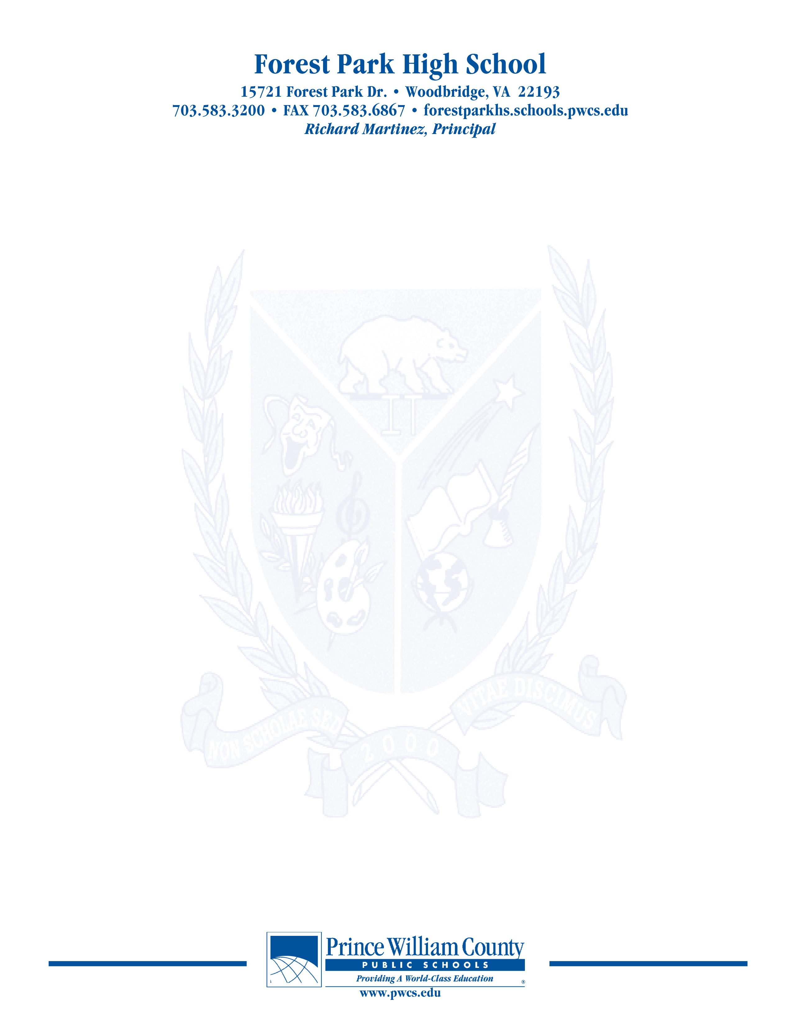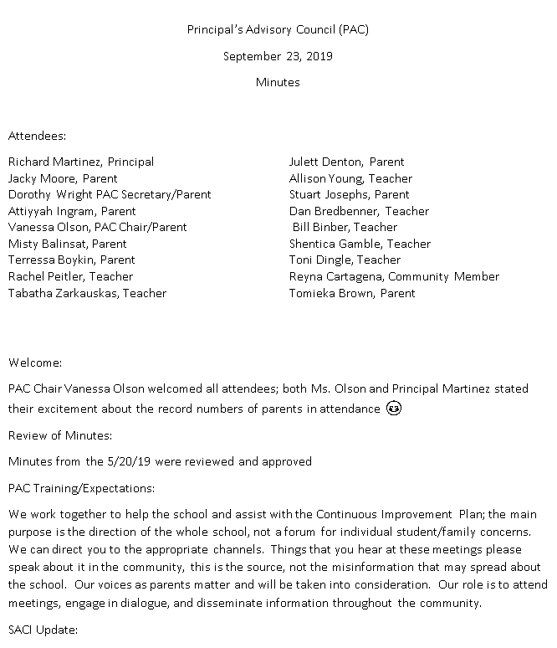

Principal’s Advisory Council (PAC)

October 21, 2019

Minutes

Attendees:

Richard Martinez, Principal Misty Balinsat, Parent

Dorothy Wright PAC Secretary/Parent Attiyya Ingram, Parent

Vanessa Olson, PAC Chair/Parent Julett Dentton, Parent

Tabatha Zarkaukas, Teacher Dan Bredbenner, Teacher

Rachel Peitler, Teacher

Teshia Biets, Parent

Tomieka Brown, Parent

Terressa Boykin, Parent

Welcome:

Mrs. Olson welcomed everyone

Review of Minutes:

Additions/Corrections: names for attendance

Enrollment number to be corrected

**Update on SACI**

Met on 10/10/19, Dr. Waltz presented 10 reasons to be excited

0ver 91,000 students

99 schools

11 million square feet of facilities

New focus on mental health

55 new counselors

Fulltime nurse at every school

Students, engagement, Twitter account, it is monitored, meets with students, he has a following

199 school events attended; will more than likely surpass that number this year; very active

Review of strategic plan—current plan runs through 2020; opportunities to contribute

The HUB—going much better than last update;

500,000 logins and 50,000 messages

November—mental health focus during next meeting; grading will also be discussed at the next meeting

Our input on grading and testing—

Parent has checked in on the HUB and there were grades that were of concern; the teacher was dismissive and suggested to parents to not be concerned about the grade.

The software company is working on the glitches in the app

Important to not only view the app, but interface with the teacher

Ombudsman to interface with—person does not solve issues but listens and explores additional options

Start times—hot topic again; funding is an issue—bus costs

Tip line will be updated as well; will be screened more and given information to administration promptly

***The purpose of the Forest Park Senior High School Principal's Advisory Council provides feedback and recommendations to the Principal pertaining to the annual school improvement plan (hereafter, “the School Plan”). The PAC is not a forum to discuss personal or individual issues relating to any particular student or parent.***

**Principal Martinez’ Report**

The HUB is not exactly where it needs to be; certain teachers don’t have access to some of the reports that they utilized in the past

The Touchbase Conferences were successful but turnout was lower than in previous years

2/10/19—next Touchbase Conference 7:30-9:45am—wait and see based upon the weather

Graduation June 5th Eagle Bank Arena at 2pm—early dismissal permission;

CIP Plan

Instructional Focus—collapsed the focal points from 5 down to 3

Met with Dr. Huckestein and Forest Park Admin

Mrs. Chapman spoke more in-depth about the plan

Gave overview of new initiatives

Standards based grading and assessment

Improve school culture

Increase student access to AP courses

Email Mrs. Chapman ideas/concerns/questions

Under projection for students

Current enrollment 2231

Will have to hire another EL Teacher

Math teacher and English Teacher will be hired that have EL backgrounds

16.9 million budget

89.1% operating budget

1.6 million in flex

Room, lighting and technology issues will be addressed

What’s Happening

Principal Martinez has joined Twitter

Ursa Major Literary Magazine

Vice-Chair Justin Wilk featured FPHS in Board Briefs

Turf Information Forthcoming

20th Anniversary Celebration

Purchase of Technology—smartboards are starting to die

Tile floor where new Macs reside

Sound in Enclosed using speakers provided by KLC

Upgrade Auditorium lighting (approx. $12K)

Upgrade Bell System (approx.$15k)

Suggestions from PAC re: Cafeteria Balances

On June 30th Mr. Martinez is given a list of balances; $50-60,000 over the past 3 years; students may not be able to participate; a parent suggested donating extra monies to other accounts that are in deficit; some parents are frustrated that school funds are being utilized to pay for cafeteria balances; if parents attempt to pay for a previous years accounts the money goes directly to the current cafeteria account, in order to pay previous years’ accounts parents must contact Principal Martinez’ financial secretary.

**Open Chair**

No comments

**Concluding Remarks & Adjournment**

We are out of time at 8:08pm

In need of bus drivers—please reach out to the community

**Our next meeting will take place on November 18, 2019**

***The purpose of the Forest Park Senior High School Principal's Advisory Council provides feedback and recommendations to the Principal pertaining to the annual school improvement plan (hereafter, “the School Plan”). The PAC is not a forum to discuss personal or individual issues relating to any particular student or parent.***