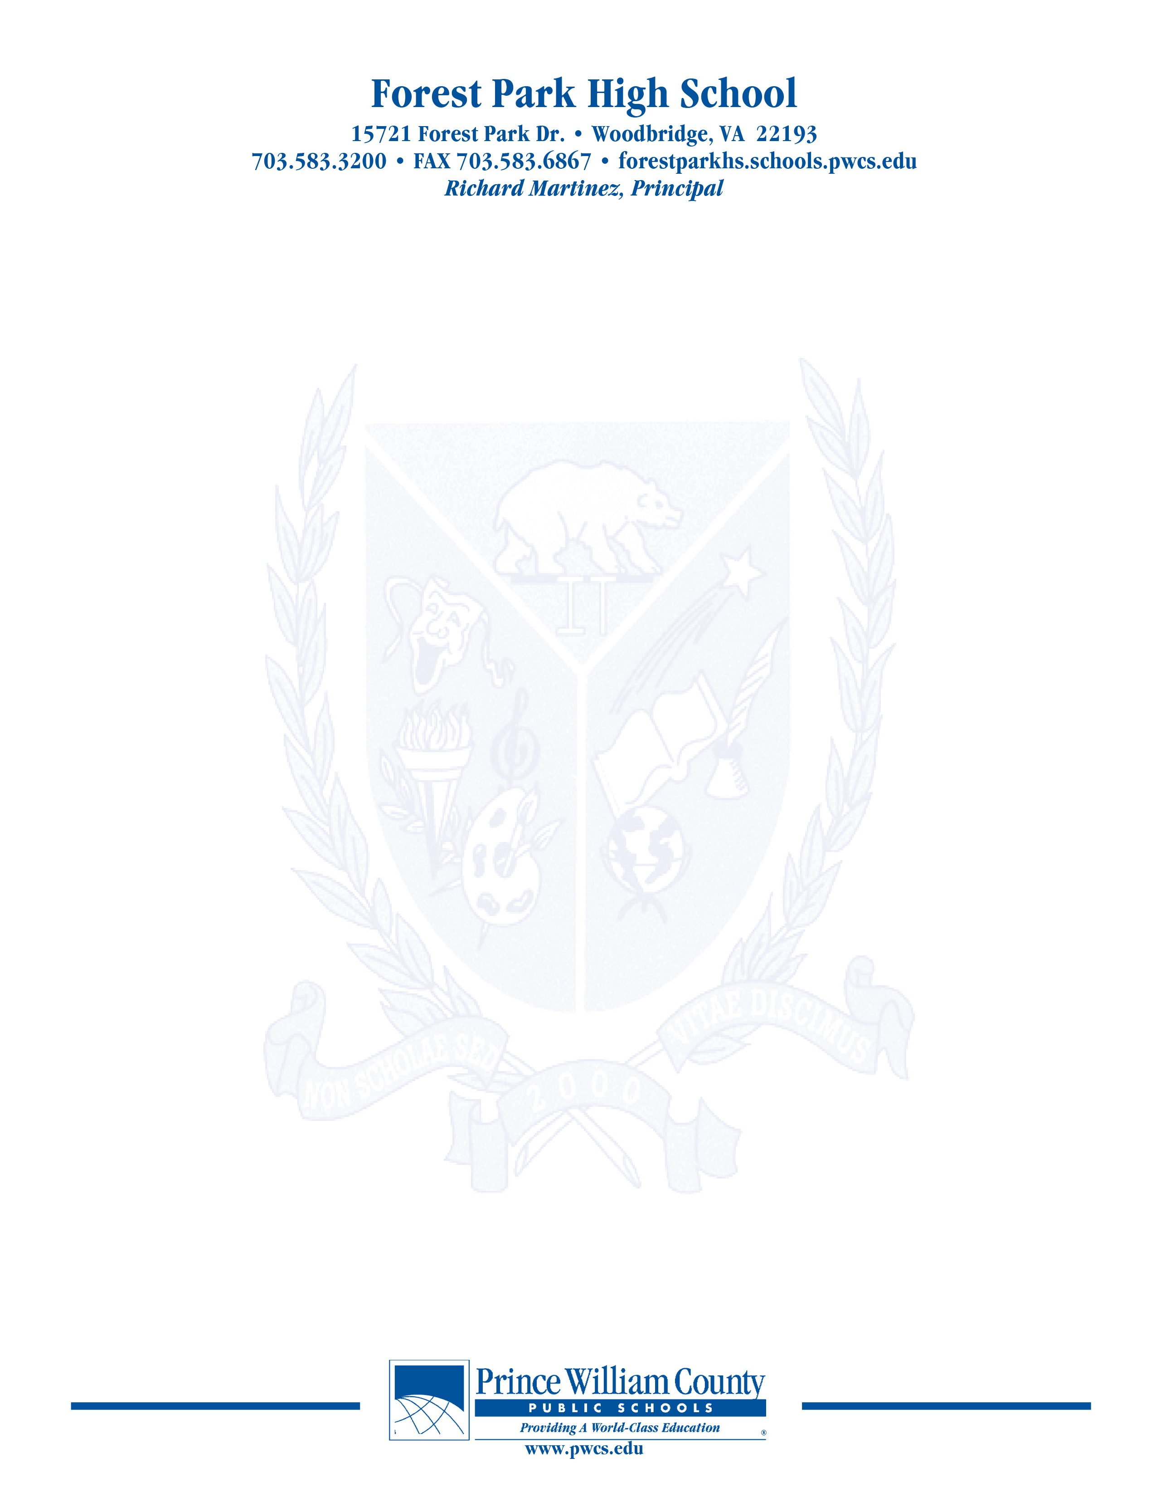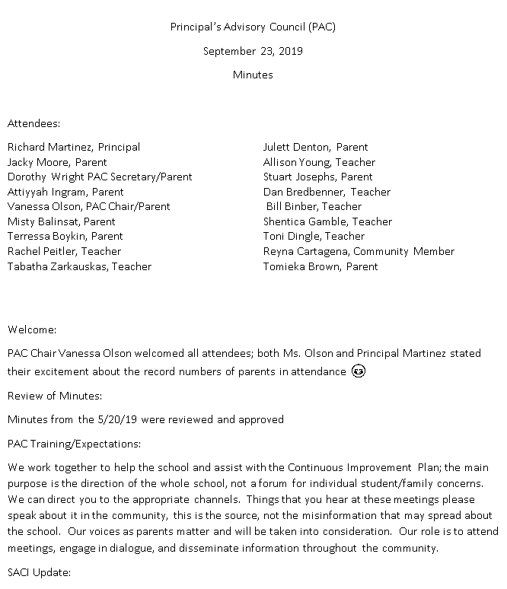

Principal’s Advisory Council (PAC)

January 13, 2020

Minutes

Attendees:

Richard Martinez, Principal Vanessa Olson, PAC Chair/Parent

Julett Denton, PAC Co-Chair/Parent Jacky Moore, Parent

Tabatha Zarkauskas, Teacher Shemica Gamble, Teacher

Allison Young, Teacher Ariyaria Brown-Watts, Student

Nicole Largen, Boosters President Dan Bredbenner, Teacher

Jen Chapman, Administration Rachel Peitler, Teacher

Toni Dingley, Teacher

**Welcome:**

Mrs. Olson welcomed everyone

**Review of Minutes:**

Approved as revised.

**Update on SACI**

* We discussed Communication
  + The Scoop- weekly newsletter emailed to over 90,000 each week.
  + E-News- sent daily to news organizations
  + The Hub
  + What is next- online registration, electronic absence reporting, ability to pay more things online such as field trips.
* Virtual High School- is free for PWCS students during the fall and spring semesters- (This is paid for by a grant from the division. If the school exceeds the grant, the overage will come from the school budget)
* Grading
  + Trying to separate academic performance from behavior in grades
  + Explicit reference to formative, summative and reassessment
  + Descriptive titles
  + Expectations of greater teacher collaboration and consistency within and across schools
  + Reassessments are supposed to be just that, not just retakes. It is not automatic, nor guaranteed. Requires demonstration of preparation to be given for the possibility of another opportunity.
  + Real World is full of second chances.

**Principal Martinez’ Report**

* Discussion of Negative Lunch balances again.
* We are coming up on the 20th Year observation. We are looking at how different groups can incorporate this celebration into their activities.
* The beginning of February it is the start of the Budget Cycle. We are looking to fill needs in English, Spanish, EL, Special Education, Math, Biology, and the Library.
* We achieved School of Excellence for the 4th time in school history.
* We had a meeting about the new turf fields in December. We are waiting to hear back from the County to approve the plan and then we can start talking dates.

***The purpose of the Forest Park Senior High School Principal's Advisory Council provides feedback and recommendations to the Principal pertaining to the annual school improvement plan (hereafter, “the School Plan”). The PAC is not a forum to discuss personal or individual issues relating to any particular student or parent.***

**Improvement Plan (Jen Chapman)**

Areas of Focus

* Standards Based Grading- We are focusing on professional development
* Collaborative learning teams- additional training for leaders of these teams
* Climate and Culture- Bruin Brags- teachers can nominate students for positive behavior. Each month there will be a focus on a specific trait. Students can also nominate staff for the same quality.
* We are in academic advising season. We are looking at how we can increase enrollment in advance programs and how we can support students. We are putting together expectations information for each class to help students to have more information so they can prepare in advance (spring/summer)
* It is the Divisionwide Survey time. Please take time to complete the survey.

**Open Chair**

Boosters Update- Nicole Largen, Boosters President

* Boosters have teamed up with the Key Club for the Chili Cook Off
* Feb 7, from 4-7 $10 to enter, $2 for tasting.
* For Staff Appriciation, we are putting together recipies from around the world. An email just went out abut this.
* Staff Appreciation week is April 20-24.
* There are funds available for teachers.

Door Security- the new intercom has been activated. Visitors must buzz to be let into the office. All visitors must have an ID.

**Concluding Remarks & Adjournment**

Adjourn 7:45

**Our next meeting will take place on February 10, 2020**

***The purpose of the Forest Park Senior High School Principal's Advisory Council provides feedback and recommendations to the Principal pertaining to the annual school improvement plan (hereafter, “the School Plan”). The PAC is not a forum to discuss personal or individual issues relating to any particular student or parent.***