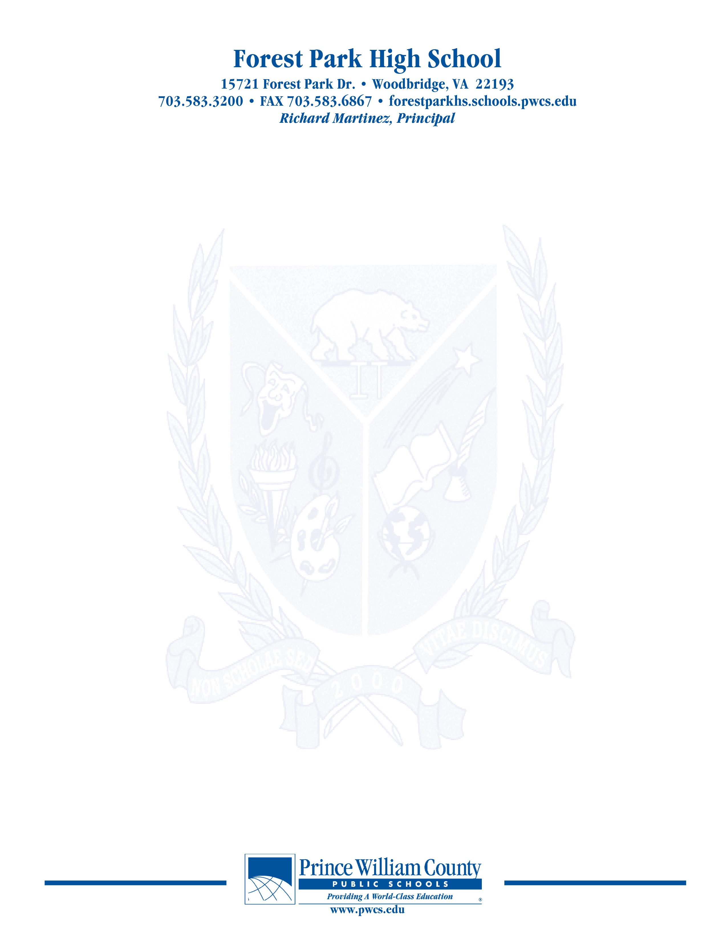

**PAC – Principal’s Advisory Council**

Monday, April 12, 2021

**7:00 pm Welcome**

**7:05 pm Update on SACI Information**

**Annual Report**

**7:15pm Elections for 2021-22 School Year**

**7:20 pm Principal Martinez’ Report-**

**Budget for 2021-22 school year**

**Security Camera Issues**

**Room configurations to support growth/mitigations**

**Senior Events**

**Celebration**

**Graduation**

**Other items.**

**7:45pm Open Chair**

**8:00 pm Concluding Remarks & Adjournment**

***Our next meeting will take place on May 3, 2021***

***The purpose of the Forest Park Senior High School Principal's Advisory Council provides feedback and recommendations to the Principal pertaining to the annual school improvement plan (hereafter, “the School Plan”). The PAC is not a forum to discuss personal or individual issues relating to any particular student or parent.***