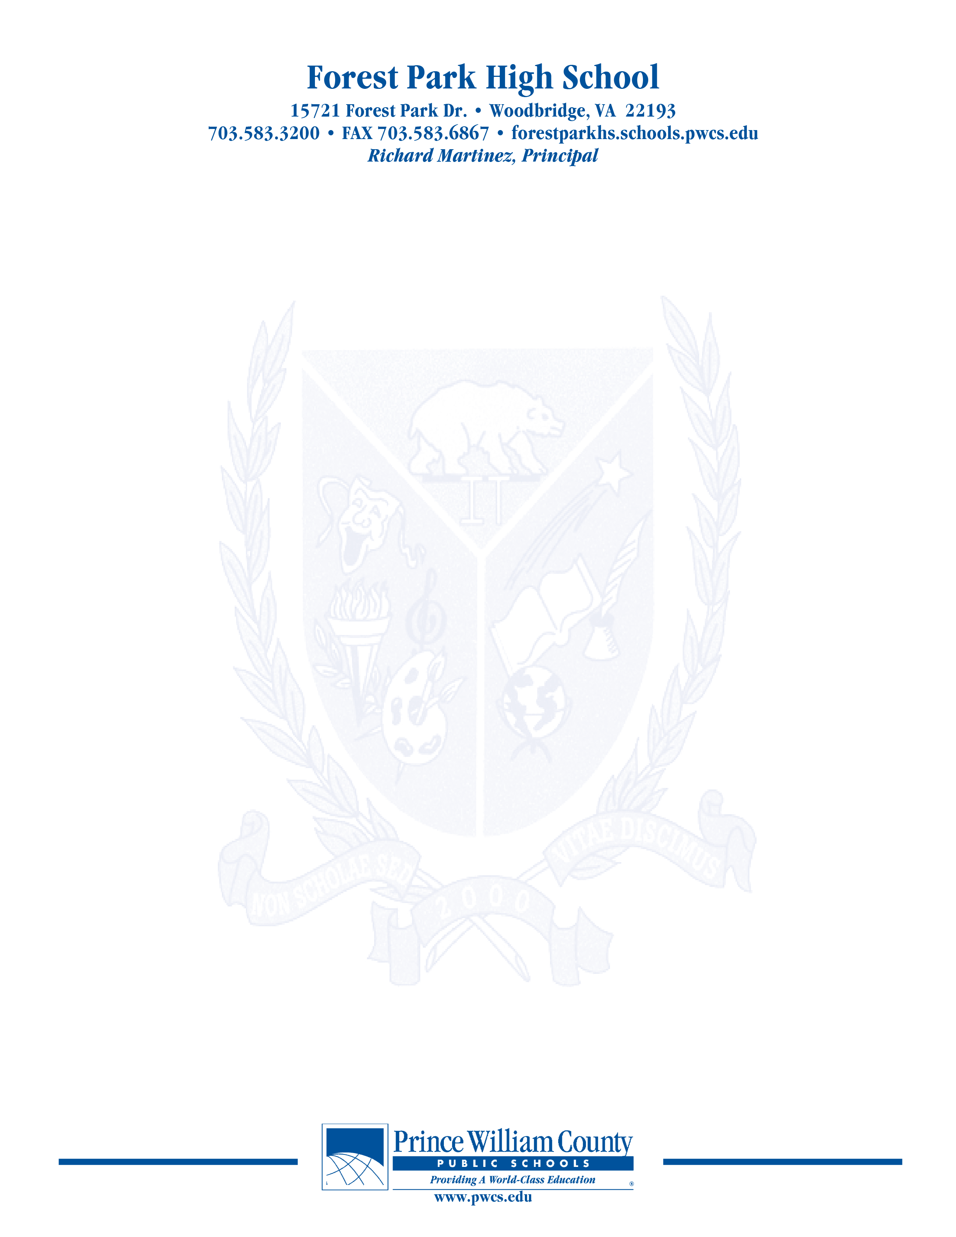
PAC – Principal’s Advisory Council
Monday, February 28, 2022

7:00 pm Welcome

7:05 pm School Highlights- What good things are happening in the Den?

710pm SACI

SACI Annual Report Update

7:20 pm Principal Martinez’ Report:

7:45pm Open Chair

8:00 pm Concluding Remarks & Adjournment

Our next meeting will take place on April 25, 2022

The purpose of the Forest Park Senior High School Principal's Advisory Council provides feedback and recommendations to the Principal pertaining to the annual school improvement plan (hereafter, “the School Plan”). The PAC is not a forum to discuss personal or individual issues relating to any particular student or parent.

