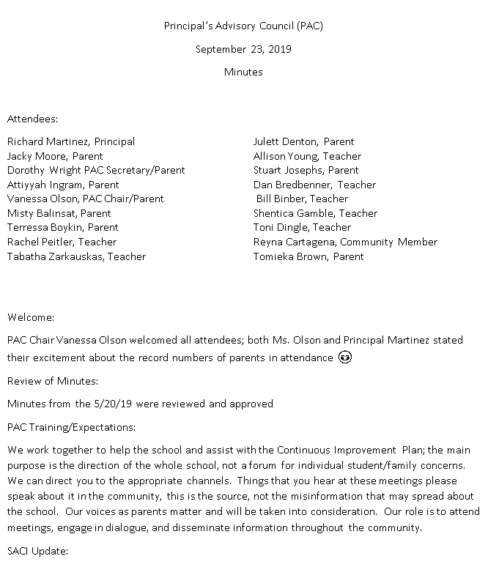
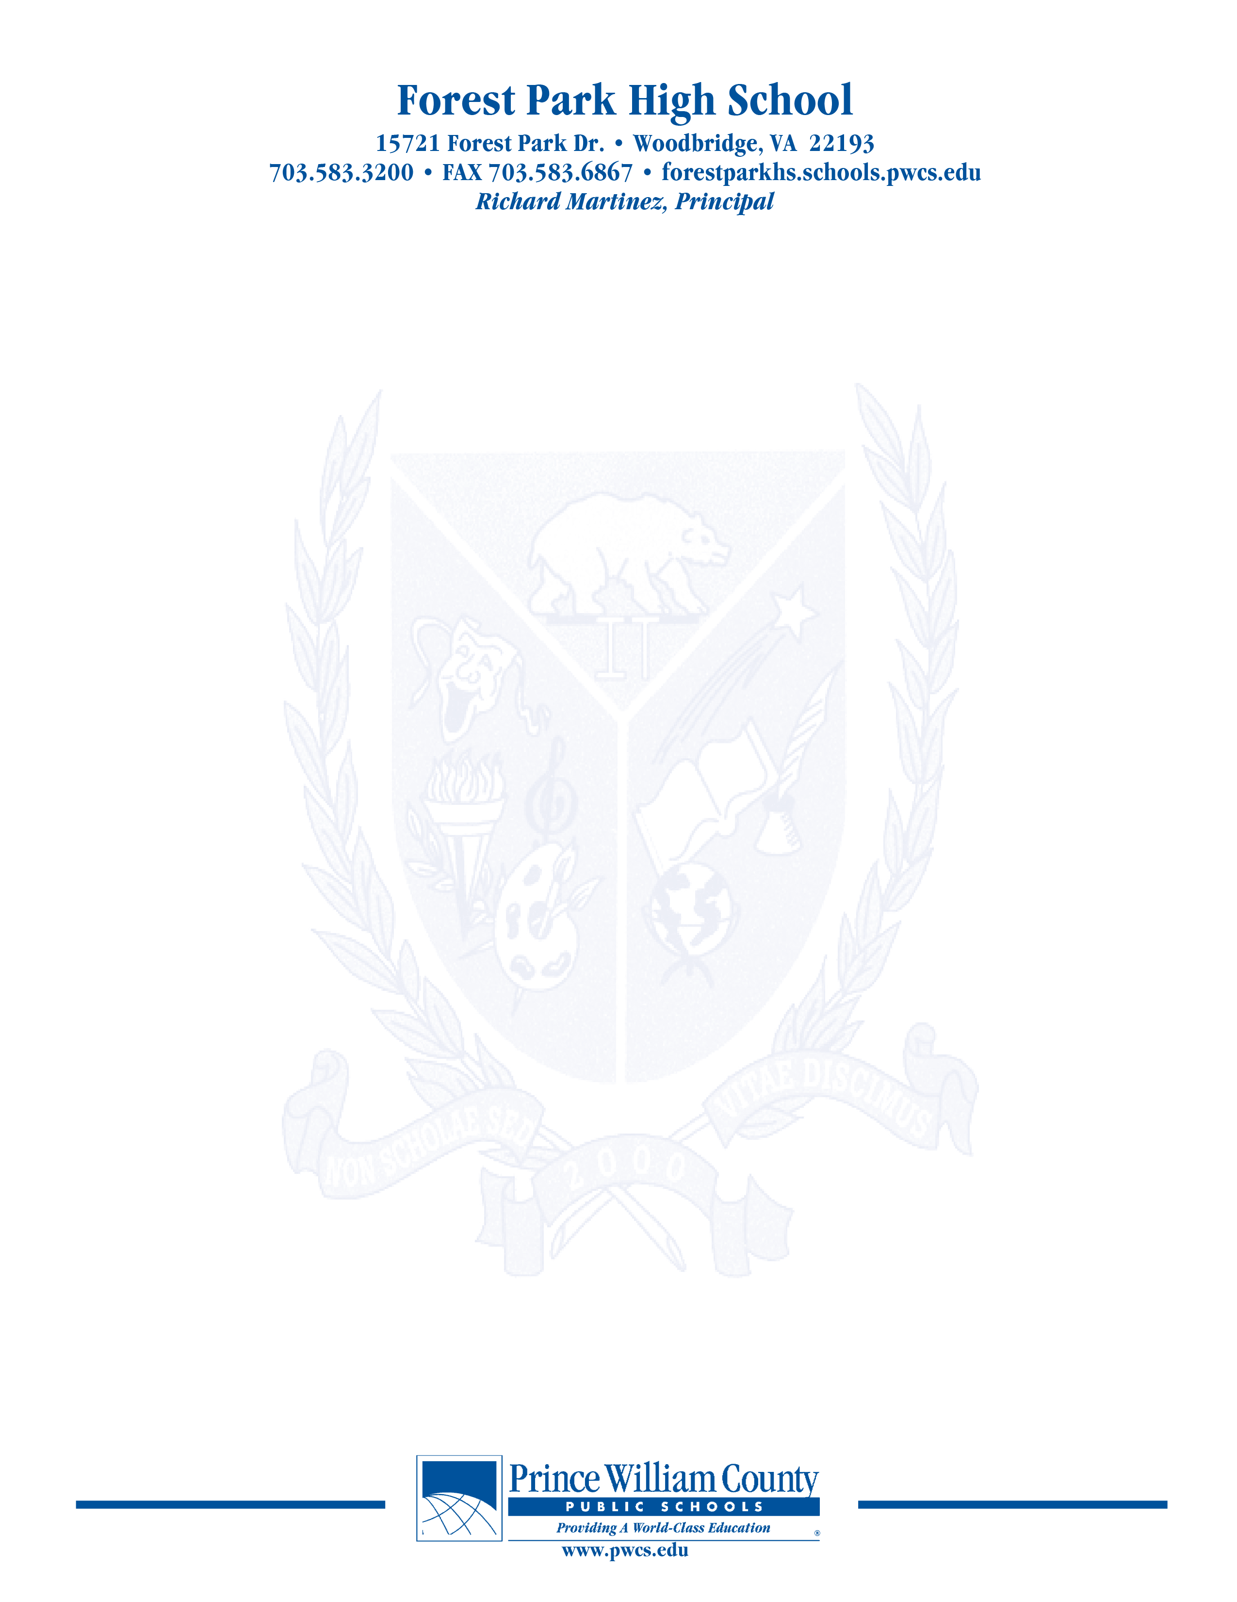

Principal’s Advisory Council (PAC)
October 21, 2019
Minutes

Attendees:
Richard Martinez, Principal Misty Balinsat, Parent
Dorothy Wright PAC Secretary/Parent Attiyya Ingram, Parent
Vanessa Olson, PAC Chair/Parent Julett Dentton, Parent
Tabatha Zarkaukas, Teacher Dan Bredbenner, Teacher
Rachel Peitler, Teacher
Teshia Biets, Parent
Tomieka Brown, Parent
Terressa Boykin, Parent

Welcome:
Mrs. Olson welcomed everyone

Review of Minutes:
Additions/Corrections: names for attendance
Enrollment number to be corrected

Update on SACI
Met on 10/10/19, Dr. Waltz presented 10 reasons to be excited
0ver 91,000 students
99 schools
11 million square feet of facilities
New focus on mental health
55 new counselors
Fulltime nurse at every school
Students, engagement, Twitter account, it is monitored, meets with students, he has a following
199 school events attended; will more than likely surpass that number this year; very active

Review of strategic plan—current plan runs through 2020; opportunities to contribute
The HUB—going much better than last update;
500,000 logins and 50,000 messages
November—mental health focus during next meeting; grading will also be discussed at the next meeting
Our input on grading and testing—
Parent has checked in on the HUB and there were grades that were of concern; the teacher was dismissive and suggested to parents to not be concerned about the grade.
The software company is working on the glitches in the app
Important to not only view the app, but interface with the teacher
Ombudsman to interface with—person does not solve issues but listens and explores additional options
Start times—hot topic again; funding is an issue—bus costs
Tip line will be updated as well; will be screened more and given information to administration promptly

The purpose of the Forest Park Senior High School Principal's Advisory Council provides feedback and recommendations to the Principal pertaining to the annual school improvement plan (hereafter, “the School Plan”). The PAC is not a forum to discuss personal or individual issues relating to any particular student or parent.

Principal Martinez’ Report
The HUB is not exactly where it needs to be; certain teachers don’t have access to some of the reports that they utilized in the past
The Touchbase Conferences were successful but turnout was lower than in previous years
2/10/19—next Touchbase Conference 7:30-9:45am—wait and see based upon the weather
Graduation June 5th Eagle Bank Arena at 2pm—early dismissal permission;
CIP Plan
Instructional Focus—collapsed the focal points from 5 down to 3
Met with Dr. Huckestein and Forest Park Admin

Mrs. Chapman spoke more in-depth about the plan
Gave overview of new initiatives
Standards based grading and assessment
Improve school culture
Increase student access to AP courses
Email Mrs. Chapman ideas/concerns/questions

Under projection for students
Current enrollment 2231
Will have to hire another EL Teacher
Math teacher and English Teacher will be hired that have EL backgrounds
16.9 million budget
89.1% operating budget
1.6 million in flex
Room, lighting and technology issues will be addressed
What’s Happening
Principal Martinez has joined Twitter
Ursa Major Literary Magazine
Vice-Chair Justin Wilk featured FPHS in Board Briefs
Turf Information Forthcoming
20th Anniversary Celebration
Purchase of Technology—smartboards are starting to die
Tile floor where new Macs reside
Sound in Enclosed using speakers provided by KLC
Upgrade Auditorium lighting (approx. $12K)
Upgrade Bell System (approx.$15k)
Suggestions from PAC re: Cafeteria Balances
On June 30th Mr. Martinez is given a list of balances; $50-60,000 over the past 3 years; students may not be able to participate; a parent suggested donating extra monies to other accounts that are in deficit; some parents are frustrated that school funds are being utilized to pay for cafeteria balances; if parents attempt to pay for a previous years accounts the money goes directly to the current cafeteria account, in order to pay previous years’ accounts parents must contact Principal Martinez’ financial secretary.
Open Chair
No comments
Concluding Remarks & Adjournment
We are out of time at 8:08pm
In need of bus drivers—please reach out to the community
Our next meeting will take place on November 18, 2019

The purpose of the Forest Park Senior High School Principal's Advisory Council provides feedback and recommendations to the Principal pertaining to the annual school improvement plan (hereafter, “the School Plan”). The PAC is not a forum to discuss personal or individual issues relating to any particular student or parent.

